**Name: Goh Fang Yao (270654)**

**Quiz 3**

**Questions:**

**• What will be printed?**

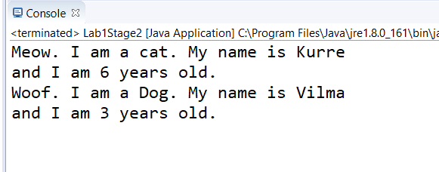

**• Explain how it is that the instance variable age of Animal can be used in Cat and Dog when it is declared in Animal.**

Animal class have subclasses Cat and Dog, the subclasses obtain all of the parent classes public and protected properties and methods through inheritance.

**• What actually consists an instance of?**

Animal object kurre is an instance of Cat while vilma is an instance of Dog.

**• And what consists a class of?**

The file Animal.java, Cat.java, Dog.java and Lab1Stage2.java consists of a classes with the same name as the file respectively. A class consists of properties and method definitions.

**• What is the difference between a class and an instance?**

A **class** is a blueprint which you use to create objects. An object is an **instance** of a **class** - it's a concrete 'thing' that you made using a specific **class**. So, 'object' and '**instance**' are the same thing, but the word '**instance**' indicates the relationship of an object to its **class**.

**• Change the declaration of the instance variable age of Animal to a class variable using static, in this way:  
public static int age;  
• What is the result of the output now? Why?**

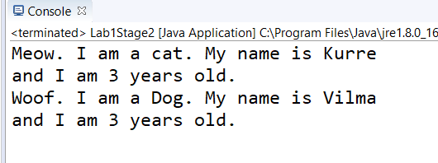

A static variable is common to all the instances (or objects) of the class because it is a class level variable. In other words you can say that only a single copy of static variable is created and shared among all the instances of the class. Therefore, when we set the age of vilma to 3, kurre's age will also be set to 3 since the age is now a static field that belongs to Animal.

**• It may happen that you get warnings from the compiler that you should access the variable age via Animal.age, but it should be possible to run the program anyway. Otherwise, change the references to age into Animal.age.  
• Where is the value of an instance variable stored?**

The value of an instance variable stored under the class it defined in. For example, the kurre and vilma instance variables were defined in the main method of class Lab1Stage2. So, kurre and vilma variables belong to of main method inside Lab1Stage2 class.

**• Where is the value of a class variable stored?**

The value of class variable stored inside a property of the class' objects. For example, age is a property of Animal. So, the age will be stored in an Animal instance.

**• What refers the variable this to?**

“This” refers to the class itself. If two variables or methods with the same name are used, “this” will make sure the current class version of the two will be used instead.